The Physics of Hydropower

Hydroelectrical Impounding Dam

Greg C., Thomas S.

Professor Ian Lilley

Physical Sciences – PHYS1001

Thursday December 8th 2016

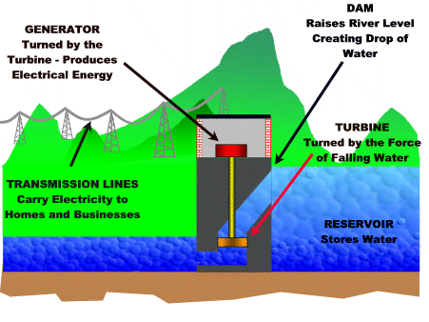Hydroelectricity is produced from the gravitational potential energy of a water basin located far above a secondary basin. The gravitational potential energy of the water is converted into kinetic energy once it enters the penstock. This kinetic energy is then converted into mechanical energy by the falling water contacting a turbine system attached to a generator. This energy then goes through a power house, meets an electrical system of transformers and moves out across powers lines to citizens within a large radius. Hydro Plants are not all the same, there are multiple types that have different ways of utilizing the gravitational potential energy of falling water. The most common type is impoundment, where a dam is built on a river to create a reservoir and then uses the pressure of the reservoir to push water through the penstock and spin the turbine to create energy.

Dams consist of an array of different components, from Trash Racks and Fish Ladders. Every part of the damn is essential in keeping the environment safe while producing efficient energy. Our energy supply starts in the reservoir, where the dam blocks the path of water to build a supply for later energy production. The reservoir is created and manipulated by a control gate blocking access to the intake. After a large enough reservoir is built up, the control gate can be used to regulate the amount of flow into the intake. Once the gate is opened water travels down the penstock at increasing speeds due to pressure and gravity. The penstock is the (usually steel) pipe water flows through which leads to the turbine that’s connected to the generator. Turning gravitational and kinetic energy into mechanical energy creating our power. The turbine is split into five parts, starting at the scroll case that leads the water from the penstock into the turbine smoothly and paths it into the guide wheel. The guide wheel is specifically used to focus the flow of water on the turbine blades. The turbine blades are a part of a system called the runner. The turbine blades-attached to the runner spins a shaft which connects to the rotor of the generator. (http://www.energy.gov/eere/water/how-hydropower-works). The stator is a case around the rotating rotor which consists of a series of magnets 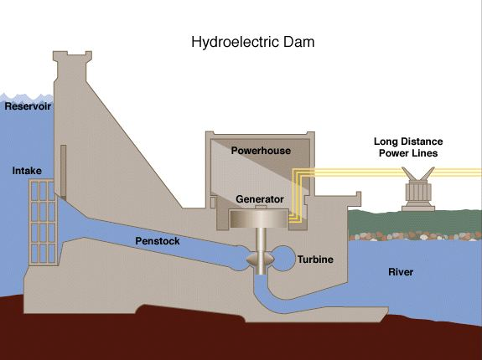which creates the magnetic field necessary for inducing an alternating electric current. The energy is then sent to a powerhouse that transforms the large current, low voltage electricity into a lower current, high voltage electricity that is more efficient for travelling through power lines. Other parts of a dam are the spillway, fish ladder and trash rack. The spillway is a structure, usually concrete and on the side of the dam, that allows water to be relieved from the reservoir. This spillway is essentially used as a safety valve if the river flow before the dam increases significantly due to rainfall or flash floods. The fish ladder is an environmentally friendly part of any dam; a fish ladder is a path split into multiple pools or water slightly higher each time for fish to migrate past the dam. A trash rack is also an environmentally friendly part to dam as it collects the trash flowing downstream keeping it out of the ocean.

Another type of dam is the diversion dam. Diversion dams do not impound water into a reservoir like its more common cousin the impounded dam. Instead, water is lead from a river or water source towards an artificially created course or canal, which then runs through hydroelectric generators and back out into the primary water source. Lastly there is pump storage dams which are dams built on a reservoir of lower elevation compared to the system. This method has two reservoirs of different elevation. Water from the lower reservoir is pumped to the upper reservoir as storage. During times where energy is in demanded it has the water flow from the upper reservoir move to the lower reservoir and when the energy is not needed it uses energy from other renewable energies to pump the water back from the lower reservoir into the upper reservoir to be used again when the energy is needed.

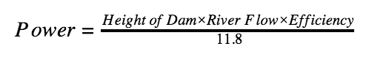

**Power = The electric power in kilowatts (one kilowatt equals 1,000 watts).**

**Height of Dam = The distance the water falls measured in feet.**

**River Flow = The amount of water flowing in the river measured in cubic feet per second.**

**Efficiency = How well the turbine and generator convert the power of falling water into electric power. For older, poorly maintained hydro plants this might be 60% (0.60) while for newer, well operated plants this might be as high as 90% (0.90).**

**11.8 =Converts units of feet and seconds into kilowatts.**

The following equation is how we calculate the volume of power the dam will produce and every factor affects the formula. The height of the dam changes the power, the further the water falls, the more power it has behind it. (http://www.wvic.com/content/how_hydropower_works.cfm) This changes the amount of power generated because scientists claim water that falls twice as far has twice the energy.(http://www.wvic.com/content/how_hydropower_works.cfm). River flow (in cubic meters per second) is related to the size of the pipe and how big the dam is. With a bigger pipe, more water can flow. Thus, there is more water applying force to the turbine blades which will generate more power. The only downside is that for more power, a larger source of water is required. Efficiency is an important variable that changes based on how old the dam is. Dams recently built have an efficiency factor of 80-90%. whereas dams that are older and maintained less usually have an efficiency factor closer to 60-80%. Lastly you need to convert the units of feet and seconds into kilowatts by dividing 11.8.

EXAMPLE EQUATION

Bernoulli’s Equation Rundown

The Bernoulli Equation is a conservation of energy formula dedicated toward fluid mechanics.

Bernoulli’s Equation -

Step 1 – Find the pressure at (assuming both velocities are 0, both cancel then we rearrange).   
Bernoulli’s Equation -

/ 2.45

Step 2 – Find (set as 0, becomes 15m)

Step 3 – Find (All aspects of the equation are taken into equation because there are both changes in height and velocity). must be converted to from

1  = 101324.997664

=

= = 50.478

Step 4 – Find the velocity at 50m in a 100m pipe ( )

Step 5 – Calculate Volumetric Flow Rate (Q)

Step 6 – Calculate Power (Watts) Assuming 85% efficiency (Units are in feet)

= 196.445

Step 7 – People served (3000W = 1 person)

Reference Page

* How Hydropower Works. (n.d.). Retrieved December 07, 2016, from http://www.wvic.com/content/how_hydropower_works.cfm
* http://img.bhs4.com/FA/8/FA89BF0370B42A4719540EFC583EFDDD331BFD22_lis.jpg

F. (2008). How hydroelectricity works. Retrieved December 07, 2016, from <http://www.youtube.com/watch?v=rnPEtwQtmGQ>

* Perlman, U. H. (n.d.). Hydroelectric power: How it works. Retrieved December 07, 2016, from http://water.usgs.gov/edu/hyhowworks.html
* How Hydropower Works. (n.d.). Retrieved December 07, 2016, from http://www.energy.gov/eere/water/how-hydropower-works
* Types of Hydropower Plants. (n.d.). Retrieved December 07, 2016, from <http://www.energy.gov/eere/water/types-hydropower-plants>
* Types of Hydropower Turbines. (n.d.). Retrieved December 07, 2016, from <http://www.energy.gov/eere/water/types-hydropower-turbines>
* Michel van
* Glossary of Hydropower Terms. (n.d.). Retrieved December 07, 2016, from http://www.energy.gov/eere/water/glossary-hydropower-terms